Montenegro Adress: St. IV crnogorske no.1 Berane municipality 84300 Berane, Montenegro
phone: +382 51 231 973
fax: +382 51 233 357
e-mail: arhitekta@berane.co.me

Service of The Chief CityArchitect 14.08.2023.year

QUESTIONS AND ANSWERS
COMPETITION FOR THE CONCEPTUAL ARCHITECTURAL AND URBAN DESIGN- THE NEW CEMETERY IN BERANE

1.Question:
1st question: I reside in Turkey and am a senior student in the department of architecture at a university in Turkey. Can I participate in the competition individually?
2nd question: Should the language of the text and graphic files we will present in the competition be English, or can we present them in our own language?
3rd question: Will deliveries be fully digital? Is it possible to explain the delivery method in Turkish?

Answer:
a) You can participate in the competition individually, but you need to fulfill the conditions of the competition, which are stated in chapter 5 of the competition announcement. Persons who have their residence or registered office in the territory of Montenegro, as well as the persons with residence or registered office in the territory of another country, may participate in the Competition, where at least one of the authors of the competition entry (individual or the author’s team leader) is a responsible person of the architectural profession. The author, or the leader of the author's team, can hire experts from other professions in order to improve the competition design.
b)Textual and graphic attachments can be presented in Montenegrin or English
c) The competition entry shall be submitted in digital form via e-mail to the address arhitekta@berane.co.me or in printed form by post office to the address: Opština Berane, IV Crnogorske brigade 1. Konkursni rad mora biti na crnogorskom ili engleskom jeziku. The competition entry must be in Montenegrin or English

2.Question:
Hello,
I am a student at the faculty of architecture and design, from Turkey. We would very much like to participate in the competition, but we could not see any specifications about it.
Do you mind if we join as students and graduated architects?
Thank you,
Have a nice day

Answer:
Persons who have their residence or registered office in the territory of Montenegro, as well as the persons with residence or registered office in the territory of another country, may participate in the Competition, where at least one of the authors of the competition entry (individual or the author’s team leader) is a responsible person of the architectural profession. The author, or the leader of the author's team, can hire experts from other professions in order to improve the competition design.

3.Question:
Hello, my name is Ege Cem Akpýnar. I am the spokesman for our group of architects “Begefan”. We were wondering where we can send you our proposal for the design? On which platform to be spesific?
Thank you kindly.
Answer:
The competition entry shall be submitted in digital form via e-mail to the address arhitekta@berane.co.me or in printed form by post office to the address: Opština Berane, IV Crnogorske brigade 1. The competition entry must be in Montenegrin or English.

4.Question:
İ want to attend to to the Competition for the conceptual architectural and urban design for the location of the new cemetery in Berane . İ would like to know that if are there any plans for the site that you are going to upload .
Thank you

Answer:
On the website of Berane municipality, in the competition documentation, in addition to the competition anouncement and competition task, there has been also published graphic documentation, which consists of a geodetic cadastral survey (dwg format) and photos of the location (pdf format).

5.Question:
I am Ömer Faruk Duman, an architect from turkey who wants to participate in the competition and is working for it.
1) I graduated from Şelçuk University in Turkey but I don't have an international diploma, will this be a problem in the later stages of the competition?
2) In the autocad drawings in the shared file attachments, the isohips lines of the project area are missing, will this problem be solved, this is very important for us in the future processes of the project.
3) When I examine the project specification, do you want us to deliver the project in a way that is printed on CD and photoblock or do you want us to deliver it only by sending an e-mail to a certain e-mail address?
4) I would like to solve the chapel and gusulhane structures separately as a single mass, but as far as I understand, the project specifications do not allow this. Can you give a more detailed explanation on this subject?

Answer:
a) The condition for participation in the competition is that at least one of the authors of the competition has a license obtained in the country from which the participant is coming from.
b) Since it is a small area which is not treated with isohypses in the geodetic survey, it cannot significantly affect the concept of the conceptual solution. Subsequently, the surveys will be finished for the needs of the main project.
c) The competition entry shall be submitted in digital form via e-mail to the address arhitekta@berane.co.me or in printed form by post office to the address: Opština Berane, IV Crnogorske brigade 1. Konkursni rad mora biti na crnogorskom ili engleskom jeziku. The competition entry must be in Montenegrin or English
d) The chapel and ghusl room are communal spaces that should be functionally connected in one complex, but with separate entrances, for the sake of the sustainability of the use of the entire complex. In this sense, the competition task does not specify the conditions and the author is given the opportunity to express his idea, which should be functional and economically viable while meeting the spatial criteria prescribed by the competition.

6.Question:
Hello!I want to ask questions:
- In the attached materials, you wrote that the language of the contest is Montenegrin. does this mean that the explanatory note and all materials must be in Montenegrin?
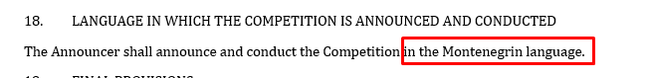
2. Is it possible to specify the details of a bank account in the Russian Federation and can a transfer be made to it if we take the prize?
3. It is necessary to submit: "- Certificate of residence for all members of the team of authors." can a scan of the passport with the place of registration be suitable for this item?
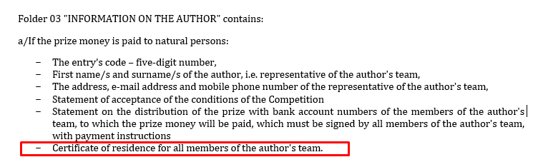
4. Where can I get a sample application "The author's statement on the payment"
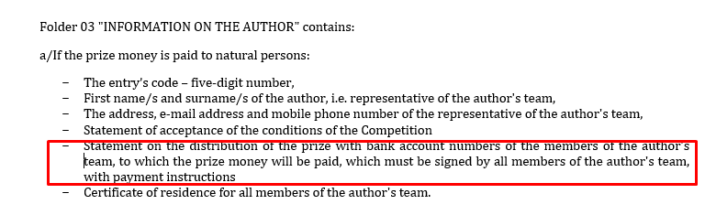
5. In what form do you need to send the applications? should these be scans with signatures?
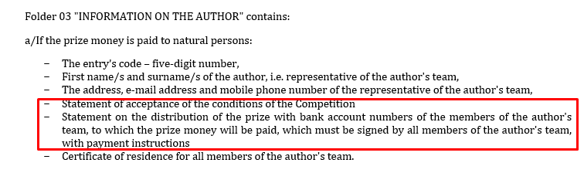
6. How is the code assigned, does our team decide what it will be?
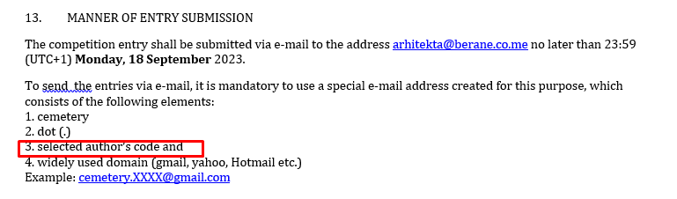
7. What is this code?
Answer:
a)The competition is international, therefore all attachments can be in Montenegrin or English.
b)Yes. You need to submit Instructions from the bank for foreign payment (which should contain the IBAN and SWIFT of the author, that is, one of the members of the author's team), to which the payment of the prize will be made.
c) Yes
d) The statement is formulated and submitted by the author himself or the author team
e) Statements can be hand-signed and then scanned or electronically signed.
f) The participant of the comeptition chooses the entry’s code himself, which must be a five-digit number.
g) The code is the work code - a five-digit number that is used to mark the competition work in order to protect the author's anonymity.

7.Question:
Hello,we would like to ask the following questions for questions and answers.
1) Can we remove the trees?
2) Can we place graves between or next to trees?
3) Are there any storey limitations for the requested buildings?
4) Can we bury the desired buildings under the ground?

Answer:
a) It is preferable to keep as much of the existing vegetation as possible, but for the purpose of a well-organized area, it is possible to remove some trees, where necessary
b) It is not desirable to plan graves directly next to trees (for root development), but it is possible to place columbariums - cassettes for urns in the wall and rosariums - graves for urns or plan a part of the cemetery with a landscape concept and apply an architectural concept on areas without vegetation. All this should be explained in the textual part. Also, it is necessary to pay attention to the route of the existing transmission line, which is drawn in the dwg attachment of KO Budimlja.
c) No, there are no storey limitations,but for the purpose of a practical and sustainable solution, it is recommended that they be on the ground floor with the possibility of planning certain rooms such as toilets, warehouses and storerooms in the basement with the planning of good ventilation.
d) No, except in the case of sanitary and warehouse premises.

8.Question:
Cemetery
How can a company or natural person get or learn the entry code?
-Is there any additional prerequisite prior to submission (for registration etc.)?
- There are noticeable emphasis on the underground water regarding cemetery zones. Is there a map or document that shows the location of such sources?
-The lack of translation of the context in the AutoCAD files makes it insufficient. Is there a change of getting these files in English?
- In the AutoCAD file there is an element called “budući dvostruki”, it is unclear what it is and it is not present in the photographic documentation. What is it?
Answer:
- The participant of the comeptition chooses the entry’s code himself, which must be a five-digit number.
- Registration is not required. Participation in the contest is free of charge. Take care that the competition entry is submitted within the specified deadline.
- There are no springs or underground water on the site, but it is considered to be in the zone for phase II (lower terrain) which is planned for future expansion and it is a wet terrain, which will be the subject of further investigations in other phases of the project implementation. Geomechanics studies for the planned location have not been done.
- No.
- It is ment on the shaft of the power distribution transmission line "future double DV10kV" and it exists in the photos with the positions of the poles that need to be paid attention to.
9.Question:
Dear Sir/Madam, in accordance with the announcement of the competition for the conceptual architectural and urban design of the location of the New Cemetery in Berane, I am addressing you with the following questions:
a) Since the existing Muslim cemetery in the context of this competition is treated as a contact zone, and on the other hand, one of the requirements of the competition is the conceptual design of the ghusl room - is it possible to envisage the partial demolition of the fence of the Muslim cemetery in order to incorporate the new facilities into the existing state and future use?
b) Are there certain restrictions regarding the positioning of supporting buildings: administrative buildings, chapels and ghusl room within the scope, ie. is it mandatory that all objects are in one unit? Is freedom allowed in their positioning on the site?
c) Are there certain guidelines/obligations regarding the preservation of existing greenery in the competition?
d) In point 12 MANNER OF TECHNICAL - DESIGN ELABORATION OF COMPETITION ENTRY it is stated that " Competition entries shall be submitted in a digital form, A0 sheets, laminated (glued on 5-10mm thick foam) in 1 copy." However, in point 13 MANNER OF ENTRY SUBMISSION it is stated that the competition entry shall be submitted via e-mail to the address arhitekta@berane.co.me. For this reason, we would like to resolve the doubt: Does the method of submission of competition entry include, in addition to the mentioned digital sending, also the submission of a sealed printed work in analog form to the archive of the Municipality of Berana? If so, is it also possible to send by post with a confirmation of the date of shipment?

Answer:
- The project assignment did not prescribe the demolition of the fence of the existing cemetery, that would require the owner's consent, which the Municipality does not have. That is why in several places that parcel was mentioned as a contact zone and as such it should be presented in terms of functional connection with the ghusl room. This parcel - that is, the existing Muslim cemetery - is not the subject of this competition. It is possible to give the idea of connecting common utility facilities with this space.
- For more efficient use of space, it is recommended that everything be in one complex, but the designer is given the freedom to express his view of the entire location in relation to the contact zones. For functionality, it is recommended that they be positioned between the burial places of both cemeteries and accessible for access from the planned road. It is up to the participants of the competition to propose the best solution for the organization of the space, taking into account the fulfillment of the conditions given by the competition task.
- It is recommended to preserve as much greenery as possible. See the answer to question no. 7.
- The competition entry shall be submitted in digital form via e-mail to the address arhitekta@berane.co.me or in printed form by post office to the address: Opština Berane, IV Crnogorske brigade 1.

10.Question:

I would like to ask the following question with regards to the competition for conceptual architectural and urban design of the structure of the new cemetery in Berane.
1. On Page 6 under item “IV SUBJECT OF CONCEPTUAL SOLUTION” , it says that “The existing Islamic cemetery should be viewed as an already formed unit for burying places and as a contact zone.” What is meant by “contact zone”?
2. The drawing “1750 Dopuna geodetsko…” doesn’t have a contour lines on the Muslim cemetery part. Is it possible to get a drawing that has topographic contour lines so that we can model the whole together?
3. On page 8 under section 3.7. it says that “The space between graves shall not be narrower than 1.5 m, and the distance between graves shall be at least 0.5 m” This is a bit ambiguous. Can you illustrate this in drawing/diagram?
4. Are the family ‘TOMBS’ going to be constructed above ground or below ground? Can you illustrate ‘the traditional method of burial in tombs’ drawing?
5. Can you illustrate the Section VIII RULES AND STANDARDS in simple diagrams/drawings?
6. From what I read on page 10, under Section F, it seems that the Chapel and the Ghusl room are to be located in the same location. Is this the suggestion?
7. How is the direction of the construction of the Orthodox cemetery? is it the tombstone that faces the east?
8. On page 11 under Section “X GUIDELINES AND RECOMMENDATIONS” it talks about waste water treatment. Is waste water treatment plant suggested or recommended for the site alone?
9. On Page 10 Item H it is stated that the parking should be “outside the boundaries of the cemetery zone” What does this mean? Is this meant to say OUTSIDE THE GIVEN PROJECT AREA or Within the project area ( out side the allocated area of (74,446m²)
10. Could we get data/statistics with regards to the population of Berane? Growth rate, death/1000, etc?
Kind Regards,

Answer:
a) The contact zone is not the subject of this competition, but in order to obtain a practical, functional and sustainable solution, it is required to look at the wider context and environment, in order to realize their functional and visual connection. See question no. 9, paragraph a.
b) This zone is not the subject of this competition zona.
c) The competition task defined that the space between the graves must not be narrower than 1.5 m, and the distance between the graves must be at least 0.5 m, referring to the distance in length and width
d) Each grave must be underground.
e) The jury is not possible to submit any sketches or proposals for the conceptual solution of the building or its parts, because the participants of the competition must not be prejudiced by the design method. It is up to the participants of the competition to offer the best solution for the organization of the space, taking into account the fulfillment of the conditions given by the competition task.
f) A joint space is planned for the accompanying facilities of both cemeteries.
g) Yes
h) There is no sewage network in the given location, so the facilities should be resolved in accordance with the Law, that is, environmental facilities for the treatment of waste water from the facilities in question should be foreseen.
i) Parking should be placed within the given scope.
j) The narrower part of Berane has 11.073 residents, while the whole municipality has 33.970 residents.

11.Question:
Dear Sir/Madam, we would like to ask you to clear up some ambiguities regarding the form of submission of the competition entry for the Competition for the conceptual architectural and urban design- the new cemetery in Berane. Namely, we noticed certain inconsistencies in the document Competition anouncement.
a)In point no.12 - MANNER OF TECHNICAL - DESIGN ELABORATION OF COMPETITION ENTRY it is stated that the competition entries are submitted in digital form by sending an email to the specified address, but in parts of this point it is stated that the A0 sheets are laminated, as well as that each A3 notebook is submitted in five copies with CDs attached to its covers, which implies the analog submission of the competition entry.
b)Also, there is another point which is not not harmonized in the Competition anouncement, and it is related to the entry’s code.
In point 12.1 it is stated that the Entry’s code consists of 6 characters, of which three are Arabic numbers and three uppercase Latin letters, while in point 12.3, on page no. 8 in the Data about the author, it is stated that the entry’s code is a five-digit number
c) We would like you to answer us whether the project is submitted exclusively in digital form?
d) Does the Entry’s code consist of three Arabic numbers and three uppercase Latin letters or of a five-digit number?

Answer:
a) The competition entry shall be submitted in digital form via e-mail to the address arhitekta@berane.co.me or in printed form by post office to the address: Opština Berane, IV Crnogorske brigade 1.

- The entry’s code is five-digit number. It is a technical error in point 12.
12.Question,
Hello Dear,
I'm Aybüke, I want to participate in the architecture competition you organize. Are there any fees when participating in the competition?
Best regards
Answer:
Participation in the contest is free of charge and no registration is required.

13.Question,

Hello Sonja,
I am an Graduate of Architecture from Australia, I am interested in the Berane Cemetery Design Competition currently being held by the Municipality of Berane.
I am writing to you regarding the process of attaining a competition entry code required for the submission of entries. Can you assist with this process?
Many thanks for your time,
Hugh Matthews

Answer:
The participant of the comeptition chooses the entry’s code himself, which must be a five-digit number.

