|  |
| --- |
| Montenegro  Municipality of Berane |



COMPETITION TASK

COMPETITION FOR CONCEPTUAL ARCHITECTURAL AND URBAN DESIGN OF THE STRUCTURE OF THE

NEW CEMETERY IN BERANE

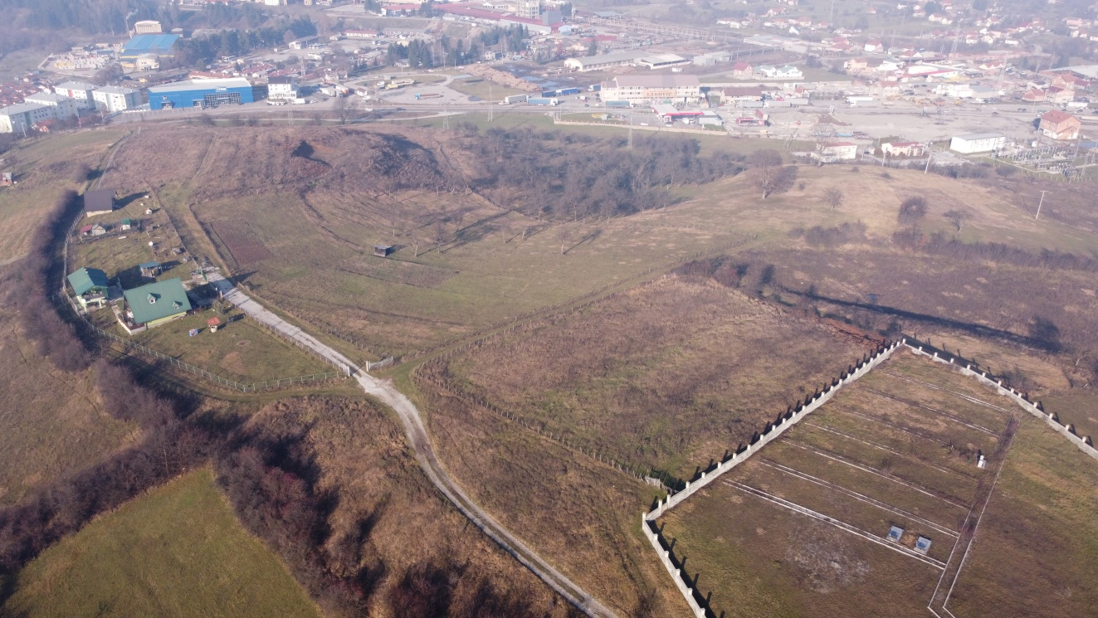

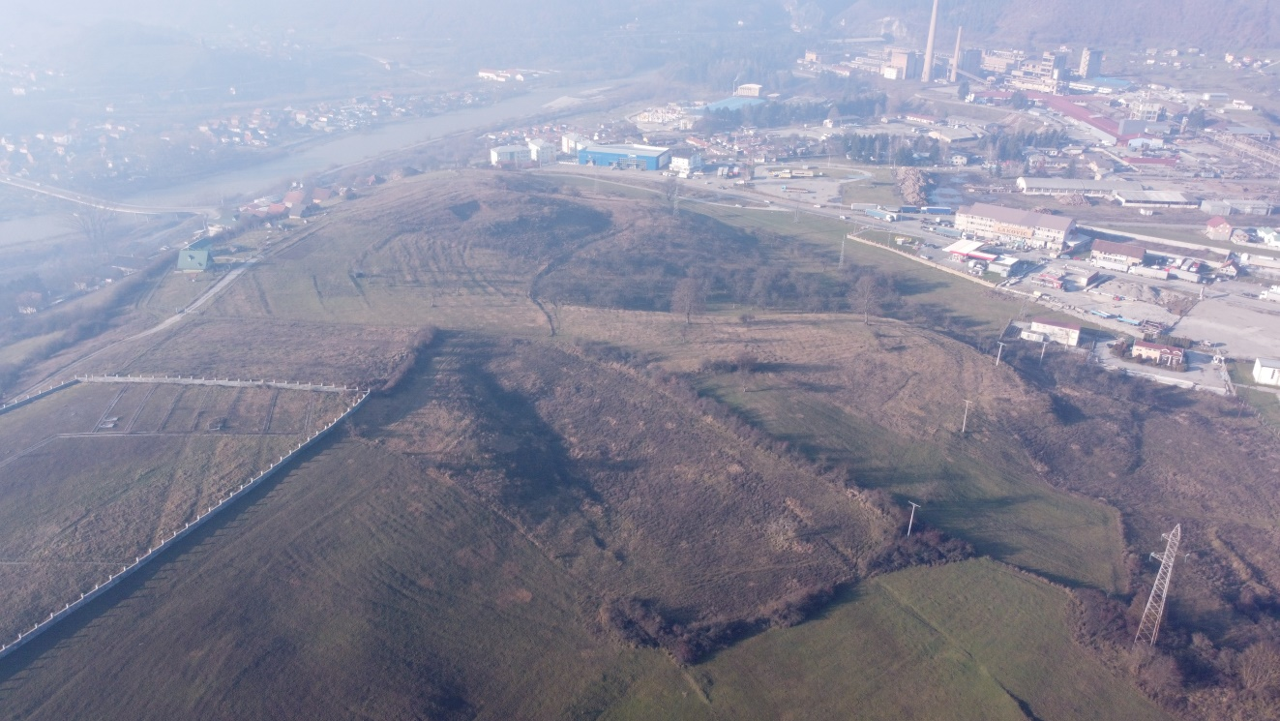

**C O N T E N T S:**

I INTRODUCTION 3

1.Selection of land and location 3

2.Shape, position and size 3

II LEGAL BASIS 5

III AIM AND PURPOSE 5

IV SUBJECT OF CONCEPTUAL SOLUTION 6

V LOCATION 6

VI CONDITIONS AND PARAMETERS FROM THE PLANNING DOCUMENT 7

1. Utility infrastructure, Cemeteries 7

2. Conditions for construction on land outside the settlement and on agricultural land 7

3. Landscaping - special purpose landscape architecture structures 8

VII RECOMMENDATIONS 8

VIII RULES AND STANDARDS 9

IX CONTENTS OF THE CONCEPTUAL DESIGN 9

1. access road, 9

2. common space between cementeries

3. a complex for burying places with internal pedestrian and vehicular traffic

X GUIDELINES AND RECOMMENDATIONS 11

XI. REGULATIONS OF SIGNIFICANCE FOR THE COMPETITION TASK 11

## **I INTRODUCTION**

The existing city cemetery is located within the scope of the "Cemetery" DUP, it has a determined boundary and area and the planned capacities are full, so the need has arisen to find and form a new area for this purpose, and the "Berane" SUP does not provide for a new location. Currently, the structure – the city chapel with three exhibition spaces and a parking space, which is on the public space next to the access street to the existing cemetery, is used within the city cemetery. In this location, it is possible to fill already formed burying places, but it is not possible to build new burying places. For this reason, a new city cemetery is planned, which will not have the central role for the entire city area.

## **Selection of land and location**

The cemetery should be planned for 70 to 100 years, and an area should be selected that will not be subject to construction and expansion of urban areas for the planned period. The location of the cemetery should be outside the city. The cemetery should be considered a free green area, and during elaboration, an attention should be paid to the fact that later, if necessary, it can also be used as a recreational free area connected to the network of other urban greenery. The cemetery may be 5 to 8 or more kilometres away from the city centre, and the border distance to the nearest agglomeration should be minimum 100 to 600 m. The distance to the cemetery depends on the topography of the terrain, so in undulating terrain, the distance may be much shorter than in flat terrain.

When selecting a location, an attention should be paid to the geological composition, the position itself and the configuration of the terrain.

If the settlement is supplied with groundwater, then it is necessary to examine the underground flow of this water and prevent the possibility of pollution of the source. Groundwater should be at a depth of minimum 2.5 to 3.00 m.

The most suitable is the soil of medium humidity, whose upper layers are made of clay, loam and loess, while the lower layers should be able to filter groundwater. The digging depth depends on the composition of the soil, so it is 1.50 to 2.00 m for adults or 0.75 to 1.00 m for children. Deep digging is not recommended due to the possibility of emergence of groundwater, but the thickness of the protective layer of soil should be minimum 1.20 m. If it is not possible to meet the conditions regarding the depth and protective layer, then melioration and drainage of the terrain and its preparation for the cemetery must be carried out.

If there is a layer of minimum 50 cm of undamaged soil between the bottom of the grave and the highest groundwater level, the soil can be considered suitable. However, if the water level of the groundwater reaches the bottom of graves, the water can in that case cause the excretion of infectious substances from the graves. The amount of organic matter that is subject to decomposition is relatively much smaller in the cemetery than in the places of waste and faeces landfills if there are no sewerage facilities.

Contamination of the air above the cemetery area can only occur if digging is done before the expiry of time for the prescribed cycle and when the decomposition process has not terminated, which lasts 7 to 8 years for adults, and about 4 years for children.

In the settlement area, the cemetery is very rarely built as a new area. In smaller towns, the same cemetery served for many generations, and in cities with a significant increase in the number of inhabitants, new cemeteries are planned which are built for the next 100 years. When determining the area, type and character of the cemetery, it is necessary to first study the mortality in the area, determine the method of burial and the required area for the burying place. According to Schuster, the number of graves per 1000 inhabitants per year can be calculated according to the following formula:

X= (0+ D/2) C / 100

where X= the number of graves per 1000 inhabitants per year,,

0= number of deceased adults per year,

D= number of deceased children under 10 per year,

C= average mortality per 1000 per year. The average death rate per 1000 inhabitants per year can be assumed to be 15.

## **Shape, position and size**

As regards their shape, cemeteries can be very different, depending on the relief of the terrain, the position of the place and the perception of the designers regarding their design. Geometric divisions of cemeteries and orthogonal schemes are more economical than free conceptions with park-landscape development.

When designing a cemetery, attention should be paid to visibility and the possibility of orientation, and in this regard, characteristic structures should be placed in such a manner that their position enables a good view of the entire location. The orthogonal scheme in most existing cemeteries is intended exclusively for burials, while in newly designed cemeteries there is a tendency to solve a free landscape environment with parks and a winding network of roads and irregular plots with free greenery. The free design method necessitates larger free terrains and a longer network of roads, because the burial areas are scattered. Undeveloped areas and the areas intended for communication in the free grouping of the landscape cemetery amount to 1/5 to 1/2 of the area intended for burial.

For several reasons, especially for technical, administrative and hygienic reasons, it would be advisable to have one central cemetery, although certain authors advocate, for technical, administrative and hygienic reasons, that it would be necessary to implement decentralization for settlements with a larger area and a number of inhabitants and settlements that increase their area. If the cemetery is placed centrally, then the entire burying takes place only in one complex, regardless of the religion and the manner of conducting the ceremony. The good side of this cemetery is the unbrokenness and centralization of the single administration and service as a public utility activity, while the bad side is manifested in cities with a large area, a large distance from certain populated parts of the city. Cemeteries could be decentralized so that the city has distributed cemetery areas according to the position of city regions. However, if, in addition to the central city cemetery, there are also peripheral ones, which were created largely due to the overgrowth of cities and the merging of certain suburban settlements, then they have local significance.

The use of the central or decentralized cemetery depends on the conditions of the terrain configuration, the suitability of the soil and the number of inhabitants. Centralization is justified for cities with up to 100,000 inhabitants. However, in cities with a larger number of inhabitants, decentralization is recommended.

The area of the cemetery is functionally dependent on the number of inhabitants and the manner of burial. The size of the cemetery increases with the rise in the number of inhabitants. Cremation reduces the need for surface area, tombs accommodate a larger number of deceased, while graves are dug up more often. If we assume that cremation will not be used in the foreseeable future, whether due to technical-economic, dogmatic habits or the habits of inhabitants, then in order to find out the necessary area for the cemetery, we would have to calculate with 100% of performing burials by placing the body into the ground.

The basic unit for determining the size of the cemetery is 2.5 m² per inhabitant, so the required area for the cemetery is approximately 5.0 ha for this location:

|  |  |
| --- | --- |
| No. OF INHABITANTS  up to..... | CEMETERY AREA  ha |
| 1.000 | 0.25ha |
| 5.000 | 1.25 |
| 10.000 | 2.5ha |
| 50.000 | 12.5ha |
| 100.000 | 25.0ha |

For the subject structure, an area of A=46,434m² has been provided for the first stage of implementation, and in the future, expansion is planned at the expense of private land up to an area of A=74,446m², which will represent the second stage of implementation. Both stages are subject to a conceptual solution.



## **II LEGAL BASIS**

The legal basis for the preparation of the conceptual urban and architectural solution, on the basis of which the technical documentation is prepared, stipulates the announcement of a public competition for the structures for the needs of state bodies, local self-government, and healthcare, educational, scientific, cultural, sports and social protection structures that are owned by the state ("Official Gazette of Montenegro" No. 64/17, 44/18, 63/18, 82/20 and 86/22)

According to Article 54 of the Law, the public competition shall be announced and conducted by the Ministry, except for the structures that are fully or partially financed from the local self-government budget, where it shall be conducted by the competent local self-government body.

The manner and procedure of announcing and conducting a public competition is prescribed by the Ministry in the Rulebook on the manner and procedure of announcing and conducting a public competition for a conceptual architectural design (Official Gazette of the Republic of Montenegro No. 19/18).

Pursuant to Article 5 of the Law, "a structure means a spatial, functional, structural, architectural, aesthetic, technical and technological or biotechnical whole with or without installations, plants and equipment being incorporated into it (buildings, engineering structures, public green areas, cemeteries, etc.) .)

Pursuant to Article 223 of the Law, it is prescribed "The regulations of the local self-government unit, governing local structures of general interest, shall apply until the adoption of the General Regulation Plan of Montenegro with reference to: water supply, telecommunications and sewerage infrastructure, hot water distribution systems; municipal roads (local and unclassified) and accompanying structures; streets in settlements and squares; parking spaces, markets; city cemeteries; underground and overhead passages; public garages, etc.

Decision on determining the location for the construction of a local structure of general interest ("Official Gazette of Montenegro - Municipal Regulations No. 13/20)

## **III AIM AND PURPOSE**

The aim of the preparation of the subject Conceptual architectural and urban solution is to carry out spatial and technical elaboration of the optimal variant of the Orthodox cemetery at a definitively determined location for both stages, in a specific scope, while proposing the manner of landscaping, and determining the forms and materialization, by taking into account the broader context and the environment.

The purpose of the competition is to make a spatial analysis of integrating the new structure/structures with all their facilities into the existing space and a detailed presentation of all the limiting factors and potential of the space. It is also necessary to adjust the shape of the subject structure/structures with the already acquired spatial and planning obligations in the immediate environment, natural environment, views.

The conceptual solution should be the basis for further detailed elaboration, development of the main project for the first stage and the basis for integration into the higher-order planning document, whose preparation is underway.

## **IV SUBJECT OF CONCEPTUAL SOLUTION**

The subject of the conceptual architectural and urban design is the construction of a new city cemetery with accompanying utility facilities, for which the boundary has been determined within the scope of cadastral plots No. 1150, 1151/2, 1151/1, 1154, 1155, 1156/1, 1156/2,1162, 1163, 1164, 1165, 1166, 1167, 1168, 1169, 1170, 1171, 1172, 1173,1 174, 1175 and a section of the cadastral plot No. 1176, all in CM Budimlja, Municipality of Berane. This scope represents the boundary of the new Orthodox cemetery in both stages.

The subject of the conceptual design also includes the construction of accompanying utility facilities and infrastructure: the chapel, the planning of internal traffic and pedestrian communications, building of access roads (main and economic) in accordance with the spatial and planning possibilities and integrating everything into the boundary of the scope and the sloped terrain for the new cemetery, and for the needs of the existing Islamic cemetery, a Ghusl room should be planned with accompanying facilities. The existing Islamic cemetery should be viewed as an already formed unit for burying places and as a contact zone. Since the existing Islamic cemetery does not have a Ghusl room and accompanying facilities within its scope, accompanying utility facilities for both cemeteries should be planned within the given location and the existing cemetery as a contact zone should only be represented graphically.

The scheme of the new cemetery with internal communications, landscaping and fencing should be planned with full attention, and adapted to the sloped terrain and the narrower and wider surroundings.

## **V LOCATION**

The planned location is situated within the scope of the urban elaboration of the Berane SUP ("Official Gazette of the Republic of Montenegro - Municipal Regulations no. 35/14), in the zone of the planned " Jasikovac polje" DUP, which has not been adopted. The determined area for the location is 74,446m², with the current intended use as agricultural land.

The location is of irregular shape on a sloping terrain. The location does not have the central role of a cemetery since the city cemetery already exists with its boundaries, chapel and accompanying facilities, whose existing graves will be used in the future.

There is a 3m wide access road on site. The access to the location is planned from the south side, from the planned city road from Harem, with a 5.5m wide roadway and 1.5m sidewalks on both sides. As the cemetery will be realized in stages, the economic access road needs to be planned from the same side.

A vehicular access refers to the access of service and intervention vehicles, and access to the parking lot, and the planned road should be treated integrally with the landscaping design.

The area covers:

|  |  |  |  |  |
| --- | --- | --- | --- | --- |
| Ord. No. | c.p.,CM Budimlja | Method of use | Area (m²) |  |
| 01 | 1150 | Pasture class 4 | 3150 | private |
| 02 | 1151/1 | Pasture class 4 | 4382 | private |
| 03 | 1151/2 | Pasture class 4 | 5145 | private |
| 04 | 1154 | Field class 4 | 6524 | private |
| 05 | 1155 | Field class 4 | 4957 | private |
| 06 | 1156/1 | Meadow class 3 | 6314 | private |
| 07 | 1156/2 | Meadow class 3 | 125 | private |
| 07 | 1162 | Orchard class 3 | 960 | Municipality |
| 08 | 1163 | Orchard class 3 | 1105 | Municipality |
| 09 | 1164 | Orchard class 3 | 1128 | Municipality |
| 10 | 1165 | Orchard class 3 | 3008 | Municipality |
| 11 | 1166 | Orchard class 3 | 2876 | Municipality |
| 12 | 1167 | Orchard class 3 | 4375 | Municipality |
| 13 | 1168 | Meadow class 4 | 7082 | in the expropriation procedure |
| 14 | 1169 | Orchard class 3 | 5125 | in the expropriation procedure |
| 15 | 1170 | Orchard class 3 | 1204 | Municipality |
| 16 | 1171 | Orchard class 3 | 4602 | Municipality |
| 17 | 1172/1 | Meadow class 4 | 3412 | Municipality |
| 17 | 1172/2 | Meadow class 4 | 2594 | in the expropriation procedure |
| 18 | 1173 | Meadow class 4 | 1818 | Municipality |
| 19 | 1174 | Uncategorized road | 527 | Municipality |
| 20 | 1175 | Field class 3 | 910 | Municipality |
| 21 | section 1176 | Area without the existing cemetery on the plot | 5.717 | Municipality |
| **TOTAL** | | | **74.446m²** |  |

The area of the existing cemetery of the Islamic community

|  |  |  |  |
| --- | --- | --- | --- |
| Ord. No. | c.p.,CM Budimlja | Method of use | Area (m²) |
| 1. | Section 1176 and section 1177 |  | 12916 m² |

## **VI CONDITIONS AND PARAMETERS FROM THE PLANNING DOCUMENT**

**SUP of the Municipality of Berane, textual part,** ("Official Gazette - Municipal Regulations", No. 35/14)

## **1. 2.5. Utility infrastructure, Cemeteries**

Suitable terrains are: with a slope of up to 10°, stable, protected from erosion and sliding, with a groundwater level: 2.5-3 m below the surface of the ground. A protective belt of greenery and a fence with the entrance-main gate have to be formed around the cemetery. The city cemetery in Berane should be developed according to a plan, and its development and maintenance, as well as the burial activities, should be the responsibility of the utility company.

## **2. 4.1.2.2. Conditions for construction on land outside the settlement and on agricultural land**

Criteria and guidelines for other utility infrastructure structures

1) Human cemeteries

The structures in cemeteries mean:

1. burial plots

2. burying places,

3. chapels (boxes) for the deceased,

4. vehicular and pedestrian roads and access road.

5. pedestrian square,

6. other facilities (religious, memorial halls, economic, flower and funeral equipment shops and other facilities for performing funeral activities),

7. green areas,

8. cemetery fence.

Minimum facilities:

- for village cemeteries: points 1, 2, 4, 7 and 8.

- Other facilities are determined according to the size, possibilities and needs of the settlement.

Before the construction of a cemetery, it is necessary to collect data on the composition of the soil, its permeability, etc., in order to avoid possible pollution and impact on groundwater and springs that are used for drinking by people and livestock.

Criteria and guidelines for cemeteries are established:

- For the construction of structures on the undeveloped part of the cemetery,

- For the legalization of structures that do not have a building permit,

- For the reconstruction of the existing structures.

The construction rules for the listed structures in cemeteries are:

1. the shape and size of burial plots are determined based on spatial conditions and functional requirements.

2. the type and dimensions of burying places are determined based on the Municipal Decision on burials and cemeteries

3. the minimum width of the pedestrian paths that divide the grave plots is 1.20 m.

4. vehicular roads (access road) are dimensioned according to the category of the road and the rank of the settlement with the minimum width of the roadway being 5.0 meters and an extremely minimum width of 2.5 meters for village cemeteries when the access is determined across a field or uncategorized road.

5. the dimensions, shape and position of the chapel and other structures are determined according to spatial possibilities, functional requirements (connection for vehicular and pedestrian traffic) and the rank and needs of the settlement. The previous paragraph refers to the legalization, reconstruction, extension of the structure and building an addition to the structure.

6. in the case where the cemetery borders residential buildings, when determining the position of grave plots in the undeveloped part of the cemetery, the border of the plot must be at least 25.0 m away from the nearest existing or planned residential building. The space between the grave plot and the boundary of the cemetery has the character of a protective green belt and must be greened with tall vegetation.

7. the fence of the complex towards the public road and undeveloped land is transparent with the height determined for residential or industrial buildings, while it is also possible to form a "living" fence. The fence on the border of the cemetery towards residential buildings from point 6 is made of masonry, industrial, provided that it does not endanger the insolation of residential buildings.

## **3. 7. Landscaping - special purpose landscape architecture structures**

Special purpose landscape architecture structures: **Cemetery**

This category of greenery is characterized by the synthesis of architecture, sculpture and garden park art, the monumental character of the composition, the specific character of the composition, the creation of a certain mood, the geometrical style of certain compositions, the specific character of vegetation, and a strictly thought-out scheme of movement. This type of green areas should be limited by the number of functional zones. Several directions of movement, of different lengths should be planned. Plan 20% of the area designated for burying places for the green belt and park-like space.

When organizing the cemetery area, it is necessary to physically separate its facilities from the surrounding uses. Within the plot, a hedge composed of autochthonous evergreen species with a dense canopy that tolerate pruning should be planned. When arranging greenery, paths and other landscaping elements, take into account the functions of burials and religious ceremonies, pedestrian movements, etc. When landscaping, combine ground floor greenery with shrubby plantings and lower trees, and tall, single trees should be used for accentuation. When choosing the planting material and composing it, take care that the greenery does not endanger tombs and graves as it grows.

**Decision on the maintenance of public cemeteries, chapels and burial in the territory of the Municipality of Berane, "Official Gazette of Montenegro" - Municipal Regulations, no. 38/2019)**

The depth of the grave shall be minimum 1.5 m, and the height of the mound 0.40 m.

The space between graves shall not be narrower than 1.5 m, and the distance between graves shall be at least 0.5 m. The family tomb shall comply with building regulations and, as a rule, should have an area of 6 m².

## **VII RECOMMENDATIONS**

The location of the new cemetery is spatially connected to the location of the existing Islamic cemetery, and it is recommended that they are viewed spatially as a single unit in terms of accompanying utility facilities.

Both cemeteries will have one entrance, a parking space for employees and visitors, a chapel/Ghusl room, an administration building with accompanying facilities, commercial spaces and a crematorium, and the internal infrastructure is planned separately.

It is also recommended that the location of the new cemetery be planned as a modern city cemetery, with blocks that, due to the slope of the terrain, need to be adapted to vehicular and pedestrian access roads. It is important that different burial methods are not planned within the same block (separate the block for urn caskets in the wall and graves for urns for which 0.92m² per urn is planned). It is also recommended that the most space (approx. 2/3 of the available space) be provided for the traditional method of burial in tombs with four places (4 people in two levels).

It is recommended that a zone for utility facilities be determined within the location, which would be functionally accessible for both cemeteries and would represent the central structures with a developed internal square for the gathering of visitors.

An important element that should be the subject of conceptual solution and which contributes to the creation of humane and aesthetically designed environment is: the materialization of public spaces (squares, plateaus, paths), benches for sitting, waste baskets, water fountains, water surfaces/fountains, canopies, pavilions /arbores, greenery, lighting.

## **VIII RULES AND STANDARDS**

- for burying 1 person in the same level or 2 people in two levels (grave width 1): length 280 cm, width 150 cm, dimensions of the opening are: length 220 cm, width 90 cm. The minimum distance between the monuments built on this type of grave cannot be narrower than 35 cm.

- for burying 2 persons in the same level (grave width 2): length 280 cm, width 210 cm, dimensions of the opening are: length 220 cm, width 180 cm. The minimum distance between the monuments built on this type of grave cannot be narrower than 35 cm.

- for burying 2 people in two levels (family tomb width 1): length 280 cm, width 190 cm, dimensions of the opening are: length 230 cm, width 140 cm. The minimum distance between the monuments built on this type of tomb cannot be narrower than 35 cm.

- for burying 4 people in two levels (family tomb width 2): length 280 cm, width 210 cm, dimensions of the opening are: length 230 cm, width 180 cm. The minimum distance between the monuments built on this type of tomb cannot be narrower than 70 cm.

The depth of all burying places is 230 cm.

## **IX CONTENTS OF THE CONCEPTUAL DESIGN**

For the location for the new cemetery, plan the overall intervention of both stages

1. access road,

2. utility facilities (relating to both cemeteries), namely: structures for the administration with accompanying facilities, a chapel and a Ghusl room with accompanying facilities, flower shop, waste disposal area, crematorium, boiler room, parking lots, etc. Plan these facilities as reference structures of the entire complex.

3. accentuated one functionally separate unit for burying places with internal pedestrian and vehicular traffic for the new cemetery (the existing Islamic cemetery is not the subject of elaboration because it has already been formed but is shown as the existing area)

1. CHAPEL WITH MORTUARY: Plan at least 3 rooms for receiving condolences of approx. 45 m² each, within which it is necessary to provide a toilet and a storeroom for relatives with one common vestibule. Each room must have a separate entrance for the family and a separate entrance for visitors. As part of this structure, toilets for visitors of approx. 30m² should be planned in an accessible place. Plan a mortuary with accompanying facilities for minimum 4 places for coffins in two levels. It is recommended that the crematorium be planned at the back of the structure (potentially next to the boiler room with ancillary rooms).

The ancillary facilities of the chapel are the serving rooms of approx. 50 m² and a kitchenette with a pantry of approx. 25 m². Plan a covered area in front of the chapel, which should be planned as a single one for all three entrances. The porch in front of the entrance is set up for shelter from the sun's rays, shelter from storms, for communication with other rooms and temporary staying of visitors, approx. 150m².

1. GHUSL ROOM: Plan the following rooms: space for ritual washing of the deceased (ghusl) of 35 m², a cooling box with a multi-level chamber for 4 deceased of 15 m², space for ritual washing of those who perform prayer (ablution) of 16 m², toilet for visitors of 30 m², rooms for displaying the deceased 2 x 25 m², serving rooms 2 x 25 m², a kitchenette next to the serving rooms with a pantry of 25 m²,

an entrance hall of approx. 50 m² and a canopy of 150 m².

1. SPACE FOR THE ADMINISTRATION: plan two offices with ancillary rooms of approx. 2x25m², space for the gardener for the maintenance of greenery of approx. 12m², tool storeroom with a workshop for occasional repairs of approx. 30m², a boiler room of approx. 30m², a storeroom for firewood of approx. 30m² and sanitary facilities for employees.
2. FLOWER SHOP: provide for a sales area with a canopy and sanitary facilities of approx. 50 m².
3. SPACE FOR WASTE DISPOSAL: for the removal of garbage and organic waste, collection points should be planned, which should be organized with complete hygienic protection and standardized containers. Plan plateaus for workers next to them, where they can easily prepare the necessary material.
4. PLATEAU FOR VISITORS: depending on the concept, plan a single plateau for the gathering of visitors until the moment of the ceremony. The area around the chapel/ghsul room should be conceived as an open space, where visitors stay, waiting to enter the chapel/ghsul room. The space needs to be furnished with the necessary furniture in aesthetic and functional terms.

The outer square provides access to both cemeteries and the organization of the cemetery service, and if necessary, it can also be used as an access for passenger vehicles.

For all of the above, a space between the Islamic cemetery and the Orthodox new cemetery has been designated where the chapel/ghsul room would be formed as the central structure in order to obtain a unique visual whole of the spatial solution. Provide access for persons with reduced mobility to all structures.

1. AREA FOR GRAVES - architectural concept

Plan the zone for the construction of graves on the basis of the planned main corridor - internal vehicular street and secondary pedestrian corridors, which must be adapted to the sloped terrain. When designing, use a rational block scheme that ensures proper geometry and quality function of access paths to all points within the complex. With this manner of space organization, take into account all models of burial methods and ensure the most rational use of space and obtain the optimal number of graves or tombs. It is forbidden to build tombs in which burials are carried out above the surface of the ground, and special attention should be paid to this by analysing the terrain and **the direction of the construction of tombs for the Orthodox cemetery**. Plan also smaller blocks for columbariums – caskets for urn in the wall and rosariums - graves for urns according to the principle and standard of 0.64m² of net area (gross area of 1.22m²) per urn place.

Within this use, the ratio of areas for burial to the areas for other facilities ranges from 60:40% in a highly architectural concept to 40:60% in a landscape concept. This functional division roughly consists of the following ratios: 60% of the area intended for graves, 20% of green belt and park-like space, 16% of the area for pedestrian paths and roads, 3% for the farewell square with the chapel facilities, and 1% for other facilities.

When arranging the graves, care should be taken to ensure that they have good communications and enough space to lower coffins. The coffin must not change its horizontal position when lowered into the grave or tomb.

Crosses and similar signs of the deceased, flowers, lanterns, vases, etc. should not be placed outside tombs or graves, as this could hamper communications.

1. PARKING SPACE: outside the boundaries of the cemetery zone, plan a parking space for employees of approx. 5 PP and for visitors of minimum 50 PP, while it is mandatory to provide parking places for the disabled in accordance with the standards.

The dimensions of the parking lot and the manipulative traffic area should be planned in accordance with the standards.

Access ramps and all the amenities that should be provided for persons with disabilities should be designed in accordance with *the Rulebook on detailed conditions and the manner of adapting structures for access and movement of persons with reduced mobility and persons with disabilities ("Official Gazette of Montenegro" No. 48/13 and 44/15) .*

1. INTERNAL ROADS AND PEDESTRIAN ZONES

Plan internal vehicular and pedestrian traffic in accordance with the solution concept within the cemetery zone. Plan vehicular-pedestrian zones with a width of minimum 4.0m and only pedestrian zones within the blocks of minimum 2.5m, using natural and local materials for cladding.

Plan lighting for all paved communications.

An access to the cargo vehicles of the cemetery service should be enabled by a special side road from the traffic square, or the access road.

1. FENCE AND ENTRANCES

Plan the fence with a maximum height of 1.4 m. It is recommended to use decorative greenery and barrier greenery so that the future structure integrates into the natural environment. The fence should have the role of emphasizing the boundary of the location and not separating the location from the environment, bearing in mind the fact that the location is surrounded by private plots with very small frontage towards public areas.

Plan the entrance gates (main and economic) as spatial benchmarks without excessive decoration.

1. UTILITY INFRASTRUCTURE

Within the scope of the burying places zone as part of the internal traffic, it is necessary to plan the distribution of water and electric power cables for the supply of electricity and for lighting within the zone, and plan fountains or decorative water surfaces in adequate places in order to maintain cleanliness and greenery, as well as in an aesthetic sense.

1. LANDSCAPING

The largest part of the location area should include landscaping for special purposes, that is, landscaping of the cemetery. A part should be designated for landscaping for public purposes, greenery along roads.

The goal of the landscaping is to create visual and physical barriers between grave fields and grave plots and to design the space for peaceful rest. Landscaping should create the "spirit of the place".

The plan envisages the design of rows of tree saplings along the pedestrian zones, as well as the creation of a complex of shrubby vegetation between the burial plots. An important element of landscaping are hedges, which have the role of separating graves and creating shade.

Landscaping guidelines are given individually for the structures as well as for squares and grave fields.

The green areas of the New Cemetery complex consist of several categories of greenery:

- Protective greenery/buffer zone

- Greenery of grave fields

- Representative greenery of the central zones

- Greenery next to the structures/tombs

## **X GUIDELINES AND RECOMMENDATIONS**

The results of verification of the basic characteristics of SUP and GUE, the analysis of the existing situation, as well as the survey of wishes of interested users of the space have determined the approach to development of this solution. The approach is based on the following positions:

* organization of facilities,
* compliance with the necessary sanitary and technical conditions,
* integration of internal vehicular and pedestrian traffic into the scheme of structures-tombs
* provision of stationary traffic with a sufficient number of parking places
* ensuring unhindered pedestrian movement within the zone and connection with external pedestrian communications,
* ensuring wastewater treatment and environmental protection,
* provision of the infrastructure network (water supply, sewerage, electrical energy and telecommunications) in order to create the necessary conditions for smooth development of the planned structure)

## **XI. REGULATIONS OF SIGNIFICANCE FOR THE COMPETITION TASK**

- Law on Spatial Planning and Construction of Structures ("Official Gazette of Montenegro", No. 64/17, 44/18, 63/18, 11/19 and 82/20)

Article 76 of the Law. The conceptual design shall set forth the general conception for a structure construction, in particular: structure integration into space; structure position within the location and in relation to adjacent structures; 3D visualization of the structure; specifications and designs for connecting the structure to transport, installation and other infrastructure and location landscaping.

The conceptual solution may also determine a structure’s staged construction (technical and technological and functional unit).

- Rulebook on detailed content and form of the planning document, land use criteria, elements of urban regulation and standardized graphic symbols ("Official Gazette of Montenegro", No. 24/10 and 33/14)

**Article 122.** The distance of a cemetery from an urban zone should not be more than 15 km. A cemetery may be located at the distance of minimum 500 m from a residential zone, and at a distance of minimum 300 m from the main roads. When determining the size of the cemetery, several factors shall be taken into consideration: number of inhabitants living in the area where the cemetery is located, the mortality rate of the population and the grave cycle (rotation tonus).

The standards for determining the area of a planned cemetery shall be 2.5 m2 per number of inhabitants living in the area where the cemetery is located. The size of a burying place shall be 2 m2, whereas the gross ground area is 3.38 m2 for a conventional burial and for storing urns - the net ground area is 0.64 m2 and the gross ground area is 1.22 m2.

The ratio of burial space to spaces allocated for other facilities shall range from 60:40% in highly architectural compositions to 40:60% in landscape compositions. This functional division shall mainly consist of the following ratios: 60% of the area intended for burying places, 20% of green belt and park spaces, 16% of the area for walkways and roads, 3% for the square where funeral procession starts to the cemetery with chapel facilities, and 1% for other facilities.

Rulebook on detailed conditions and methods of adapting facilities for access and movement of persons with reduced mobility and persons with disabilities ("Official Gazette of Montenegro", no. 48/13 and 44/15)

- Rulebook on the manner of preparation and contents of technical documentation ("Official Gazette of Montenegro", no. 44/18 and 43/19)

Article 10 stipulates that when preparing a conceptual design, the textual documentation of the conceptual design contains a technical description of the designed structure with the indication of the required utility capacities, and for buildings with special reference to the materialization and treatment of the surfaces of the cover elements (facades and roofs), elements of the carpentry/locksmith frame and additional facade elements (balcony fences, brise soleils and decorative elements), as well as the materialization and treatment of surfaces as part of landscaping, signed by the chief engineer.

Article 12 stipulates that, when the conceptual design is being prepared, the numerical documentation of the conceptual design of the building contains a representation of the surfaces of the structure with intended uses and the number of functional units.

Article 13 stipulates: In all graphical attachments in which the relative elevations of the structure are entered, it is necessary to enter the information about which absolute elevation corresponds to the relative zero elevation of the structure. All graphical attachments should be signed by the chief and responsible designer on form 6.

The graphical documentation of the conceptual design contains graphical attachments in the appropriate scale, namely:

1) a layout plan with the position of the structure at the location, shown outline, dimensions, characteristic elevations, distance from adjacent plots and structures, as well as with a representation of existing structures;

2) a site plan with the conceptual landscape design;

3) the appearance of utility facilities with the appearance of the roof;

4) bases, characteristic sections; and

5) 3D visualization showing the existing environment.